## **Summary: Uploading dataset on BigQuery**

## 

# Upload the store transactions dataset to BigQuery

In the next video, the instructor uses a specific dataset. The instructions in this reading are provided for you to upload the same dataset in your BigQuery console so you can follow along.

You must have a BigQuery account to follow along. If you have hopped around courses, [Using BigQuery](https://www.coursera.org/learn/data-preparation/supplement/DYOQK/using-bigquery) in the **Prepare Data for Exploration** course covers how to set up a BigQuery account.

## **Prepare for the next video**

* First, download the CSV file from the attachment below.

**[Lauren's Furniture Store Transaction Table](https://d3c33hcgiwev3.cloudfront.net/Hhbf0PXYQVmW39D12OFZ8A_ef465a1628a943b98ba9d0e7696877f1_Lauren-s-Furniture-Store-Transaction-Table.csv?Expires=1675382400&Signature=NGg67ksuzxn8uF0GAE4tqfN~x7kDOSgcaUUOhkPn109LfJ7cQIiJc~pBmb2ktA4wt4vkiPSB0eWGpbjaIwFleBAQ9XK6YJ0f8Zs0POhGru4pTFMkDnY2HVFCgqXHRO2lQyl4pS~LyFAJLTu9aSR-cQZrkBYIsy0B7atl5QrfC8s_&Key-Pair-Id=APKAJLTNE6QMUY6HBC5A)**

[CSV File](https://d3c33hcgiwev3.cloudfront.net/Hhbf0PXYQVmW39D12OFZ8A_ef465a1628a943b98ba9d0e7696877f1_Lauren-s-Furniture-Store-Transaction-Table.csv?Expires=1675382400&Signature=NGg67ksuzxn8uF0GAE4tqfN~x7kDOSgcaUUOhkPn109LfJ7cQIiJc~pBmb2ktA4wt4vkiPSB0eWGpbjaIwFleBAQ9XK6YJ0f8Zs0POhGru4pTFMkDnY2HVFCgqXHRO2lQyl4pS~LyFAJLTu9aSR-cQZrkBYIsy0B7atl5QrfC8s_&Key-Pair-Id=APKAJLTNE6QMUY6HBC5A)

* Next, complete the steps below in your BigQuery console to upload the Store Transaction dataset.

**Note:** These steps will be different from what you performed before. In previous instances, you selected the Auto detect check box to allow BigQuery to auto-detect the schema. This time, you will choose to create the schema by editing it as text. This method can be used when BigQuery doesn't automatically set the desired type for a particular field. In this case, you will specify STRING instead of FLOAT as the type for the purchase_price field.

**Step 1**: Open your BigQuery console and click on the project you want to upload the data to. If you already created a **customer_data** dataset for your project, jump to step 5; otherwise, continue with step 2.

**Step 2:** In the Explorer on the left, click the Actions icon (three vertical dots) next to your project name and select **Create dataset**.

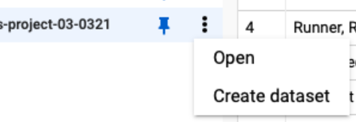

**Step 3:** Enter **customer_data** for the Dataset ID.

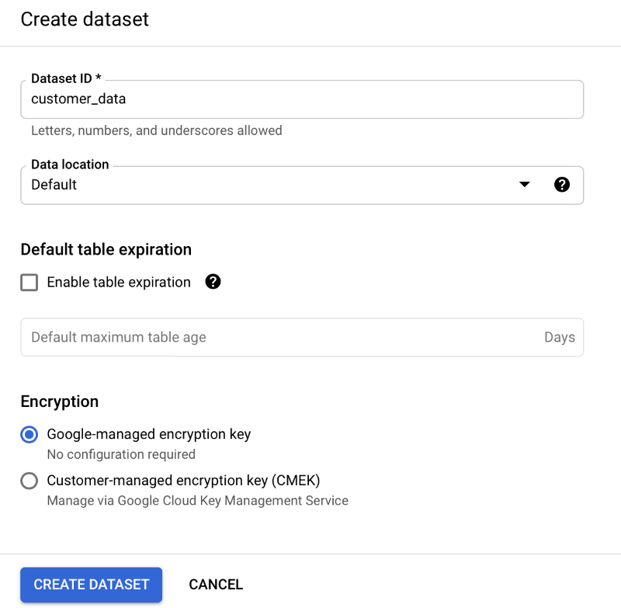

**Step 4:** Click **CREATE DATASET** (blue button) to add the dataset to your project.

**Step 5:** In the Explorer, click to expand your project, and then click the **customer_data** dataset.

**Step 6:** Click the Actions icon (three vertical dots) next to customer_data and select **Open**.

**Step 7:** Click the blue **+** icon at the top right to open the Create table window.

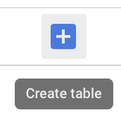

**Step 8:** Under Source, for the Create table from selection, choose where the data will be coming from.

* Select **Upload**.
* Click **Browse** to select the Store Transaction Table CSV file you downloaded.
* Choose **CSV** from the file format drop-down.

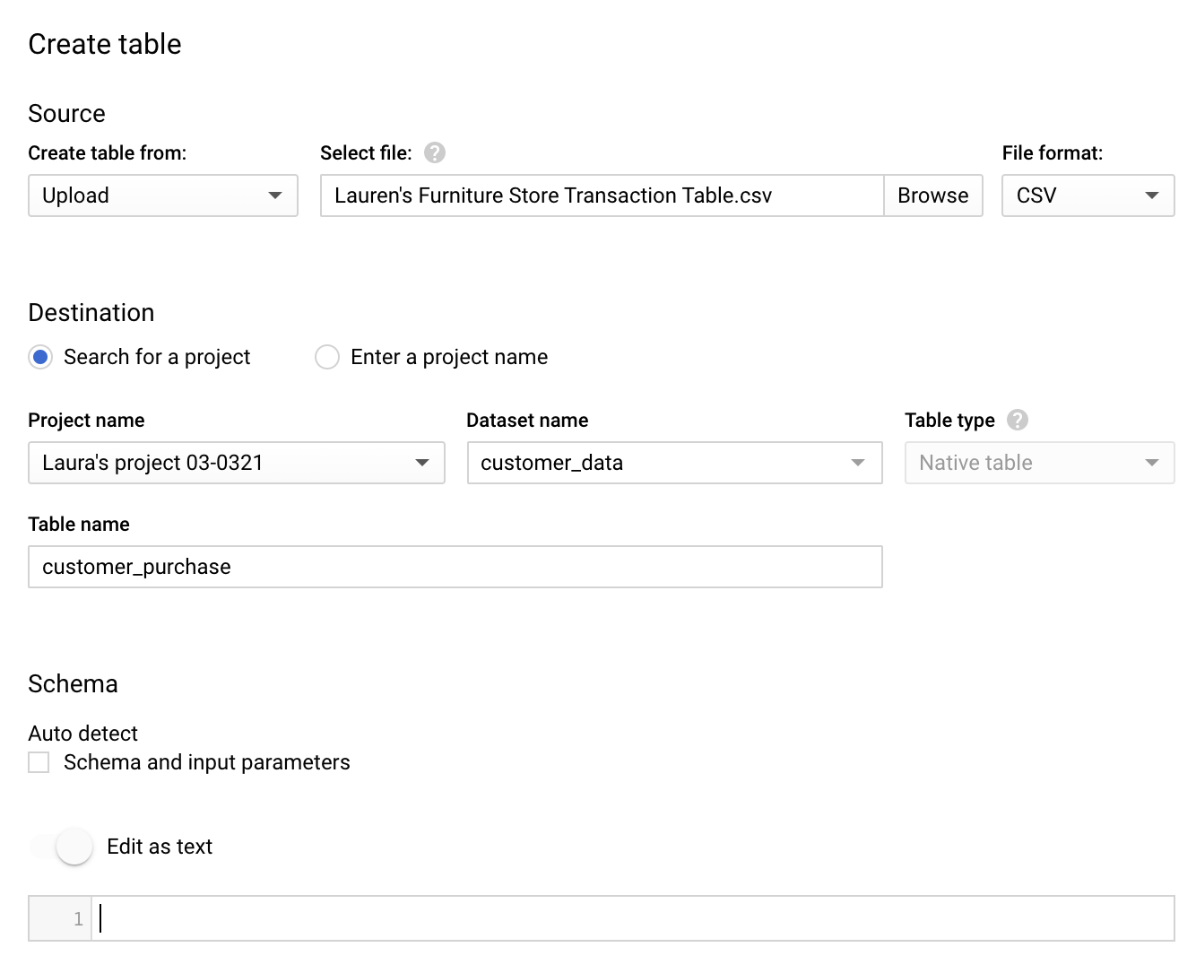

**Step 9:** For Table name, enter **customer_purchase** if you plan to follow along with the video.

**Step 10:** For Schema, click the toggle switch for **Edit as text**. This opens up a box for the text.

**Step 11:** Copy and paste the following text into the box. Be sure to include the opening and closing brackets. They are required.

[

{

"description": "date",

"mode": "NULLABLE",

"name": "date",

"type": "DATETIME"

},

{

"description": "transaction id",

"mode": "NULLABLE",

"name": "transaction_id",

"type": "INTEGER"

},

{

"description": "customer id",

"mode": "NULLABLE",

"name": "customer_id",

"type": "INTEGER"

},

{

"description": "product name",

"mode": "NULLABLE",

"name": "product",

"type": "STRING"

},

{

"description": "product_code",

"mode": "NULLABLE",

"name": "product_code",

"type": "STRING"

},

{

"description": "product color",

"mode": "NULLABLE",

"name": "product_color",

"type": "STRING"

},

{

"description": "product price",

"mode": "NULLABLE",

"name": "product_price",

"type": "FLOAT"

},

{

"description": "quantity purchased",

"mode": "NULLABLE",

"name": "purchase_size",

"type": "INTEGER"

},

{

"description": "purchase price",

"mode": "NULLABLE",

"name": "purchase_price",

"type": "STRING"

},

{

"description": "revenue",

"mode": "NULLABLE",

"name": "revenue",

"type": "FLOAT"

}

]

**Step 12:** Scroll down and expand the **Advanced options** section.

**Step 13:** For the **Header rows to skip** field, enter **1**.

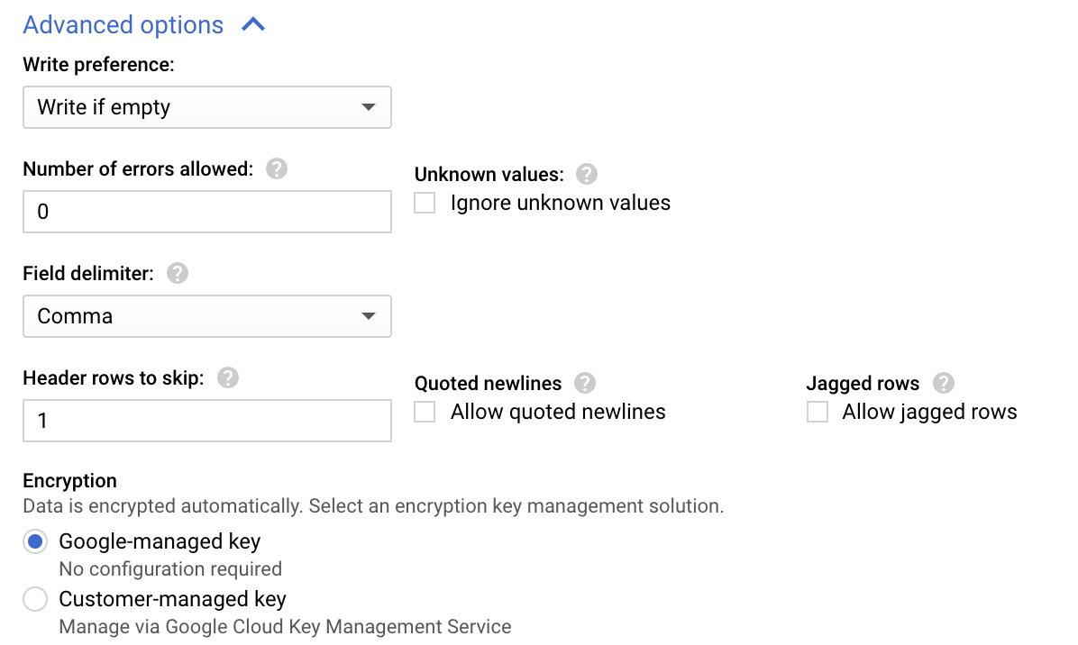

**Step 14:** Click **Create** **table** (blue button). You will now see the **customer_purchase** table under your **customer_data** dataset in your project.

**Step 15:** Click the **customer_purchase** table and in the **Schema** tab, confirm that the schema matches the schema shown below.

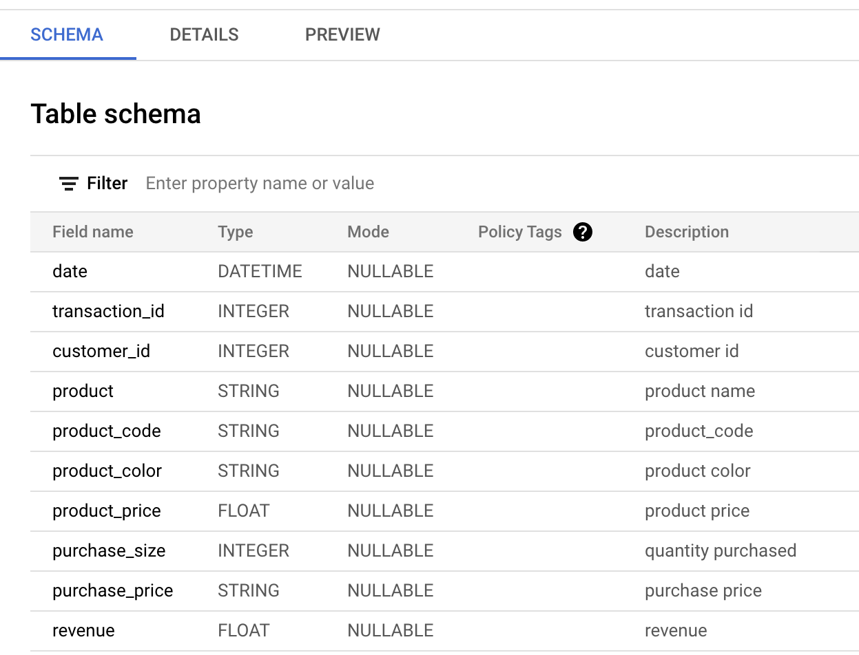

**Step 16:** Click the **Preview** tab and confirm that your data matches the data shown below.

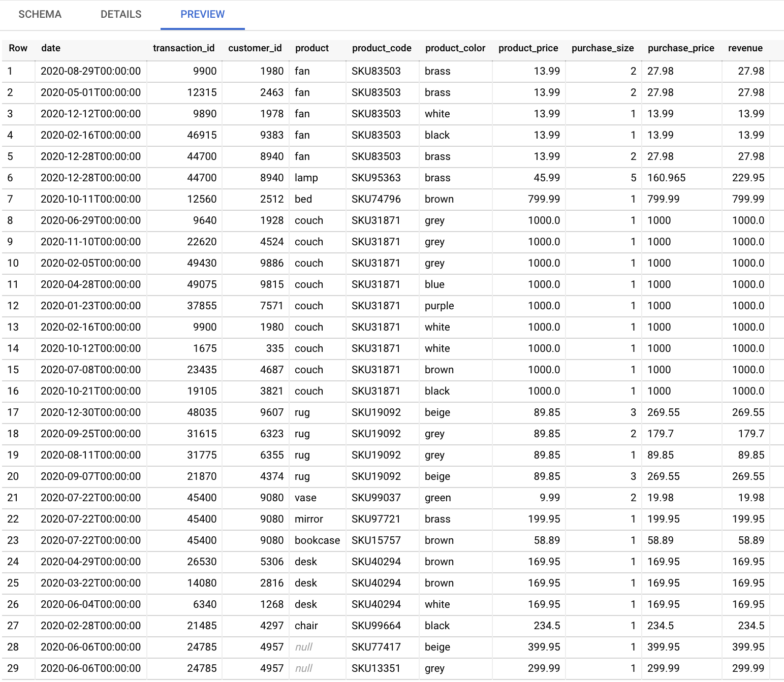

Congratulations, you are now ready to follow along with the video!